Q1. C++ program to add two time by passing objects as function argument(Call by value) (5Marks)

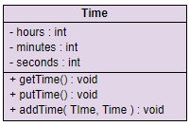

Q2. WAP C++ program to add two complex by passing object as argument to friend function

(Call by value) (10Marks)

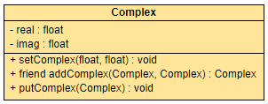

Q3. WAP C++program to illustrate the concept of operator overloading with example (10Marks)

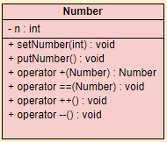

Q4. To design the template with HTML and CSS ( 25 Marks )

